
FURTHER MATHS
TRIAL EXAM 2
SOLUTIONS
2004

_____________________________________________________________________

Section A – Core - solutions

Question 1

- Use the statistical function on your calculator to find these 1-Variable stats.
Mean = 17.7, standard deviation = 3.2
(1 mark) (1 mark)

- i. From the box plot, we see that the shape of the data is symmetrical.
(1 mark)

  - The median is 7.5.
(1 mark)

  - 6 is the first quartile.
9 is the third quartile.
The percentage of data that lies between the first and the third quartiles is 50%, hence the percentage of data that lies between 6 and 9 is 50%.
(1 mark)

- To fit a least squares regression line it has been assumed that the relationship is linear.
(1 mark)

- Again, using a calculator, the equation of the least squares regression line is
number of incoming emails
(2 marks)

- If the number of outgoing emails was 15, then
number of incoming emails
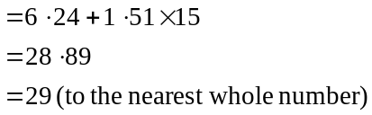
(1 mark)

- For student F the actual number of incoming emails was 12. The number predicted by the least squares regression line is
So the least squares regression line overestimates the number of incoming emails by 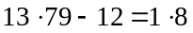 emails.
(1 mark)
- i. Using a calculator 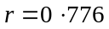
(1 mark)

- 60% of the variation in the number of incoming emails can be explained by the variation in the number of outgoing emails since the coefficient of determination is 0.60 (to 2 decimal places)
(1 mark)

Question 2

Type of email(s) | Gender of student
Type of email(s) | Male | Female
Outgoing email(s) | 35% | 52%
Incoming email(s) | 65% | 48%
Total | 100% | 100%
(1 mark)

- By percentaging the table in this way, we are comparing males with females.
(1 mark)

- From Table 3, which has been percentaged, we note that males don’t send emails as much as females but tend to receive more emails than females.
(1 mark)

Total 15 marks

Module 1: Number Patterns and Applications

Question 1

- Vertical height of sixth step above the ground floor
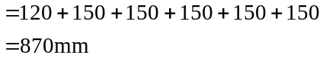
(1 mark)
- 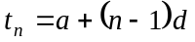 where a is the first term in the sequence. The distance above the floor of the first step is 120mm. So 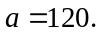 (1 mark)
The difference in height between the subsequent steps is 150mm.
So, 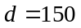. (1 mark)
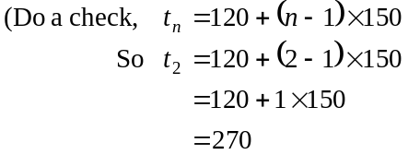
which is the height of the second step above the ground floor.
If you have time, check and so on.)

- Method 1
Using the formula from part b.
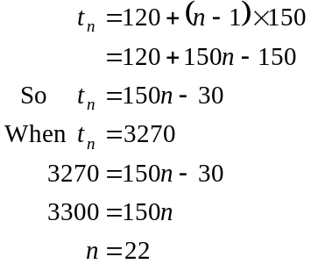
There are 22 steps.
(1 mark)

Method 2
The first step is 120mm high.
Now 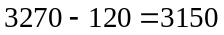
The remaining steps are all 150mm high. So 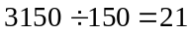.
There are in total 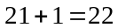 steps.
(1 mark)
- We are summing the vertical distance above the ground floor of each of the first 10 steps of the staircase.
From the formulae sheet,
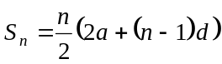 (1 mark)
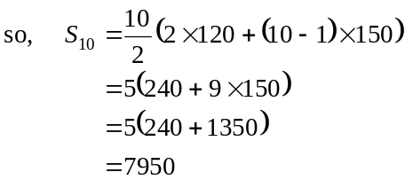
The total length of timber required is 7950mm.
(1 mark)
Question 2

- Method 1
Vertical rise of second step
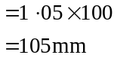
(1 mark)

Method 2
Vertical rise of second step
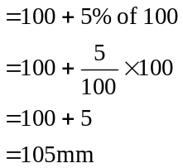
1 mark)

- The vertical rise of the n^{th} step is a geometric sequence with 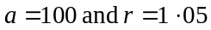.
The general term for a term of a geometric sequence is
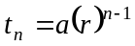
In our case,
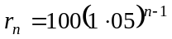 as required.
(1 mark) for correct explanation

- From part b.,
When 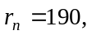
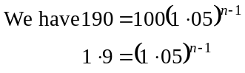
We need to solve this for n.

Method 1
Trial and error using a calculator
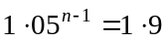
(1 mark)
The number of steps that can be legally constructed is 14. Since the 14th step will be just under the legal limit. The 15th step would be just over the limit.
(1 mark) for answer

Method 2
Use logs.
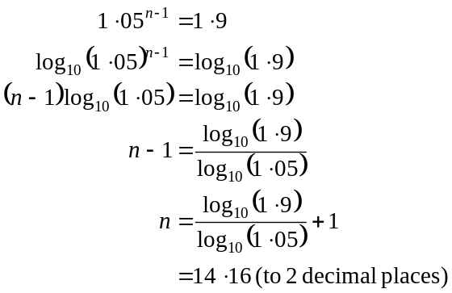
(1 mark)
The number of steps that can be legally constructed is the next whole number below 14.16 which is 14.
(1 mark)

Question 3

- 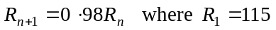
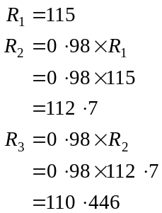
So the vertical rise of the third step is 110.446 mm. (1 mark)

- Each term in the sequence described by the difference equation 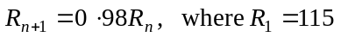 is 0.98 times the value of the previous term.
So, there is a common ratio of 0.98. This sequence is therefore a geometric sequence.
(1 mark) for answer
(1 mark) for explanation

- Because the pattern in the step height is described by a geometric sequence, we use the sum of an infinite geometric sequence.
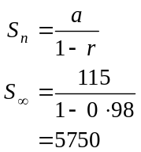
The total vertical height of the staircase would be 5750mm.
(1 mark) recognition of need for sum
of geometric series formula
(1 mark) correct answer
Total 15 marks

Module 2: Geometry and Trigonometry

Question 1

- In ΔABD,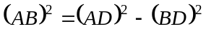
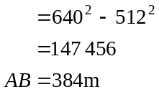
(1 mark)

- Area of 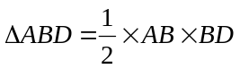
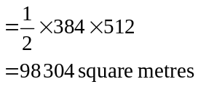
(1 mark)
- In 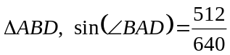
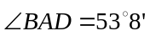
as required.
(1 mark)

- Since , then
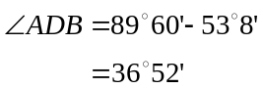
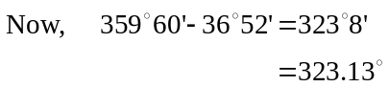
So the bearing of A from D is 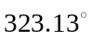.
(1 mark)
- In 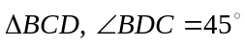

Method 1
So 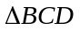 is an isosceles triangle since 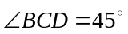.
Hence 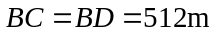 (1 mark)

Method 2
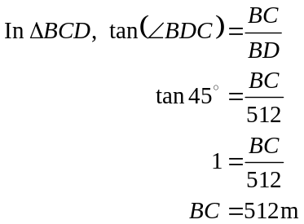
(1 mark)

Question 2

- Since BE is parallel to CD, ΔABE is similar to ΔACD. (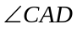 is common,  (alternate angles) and  (alternate angles))
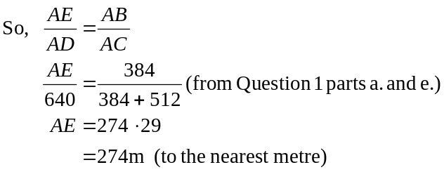
(1 mark)
(1 mark)

- since ΔABE is similar to ΔACD.
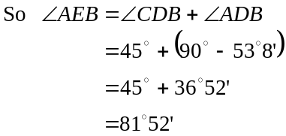
(1 mark)

- Hence means that you must use what you have just found.
In ΔABE
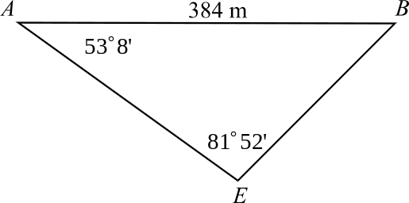

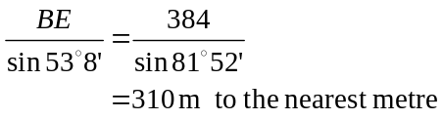

(1 mark) using the sine rule
(1 mark) correct answer

- In ΔABE
(1 mark)
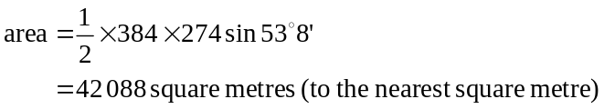
(1 mark)

Question 3
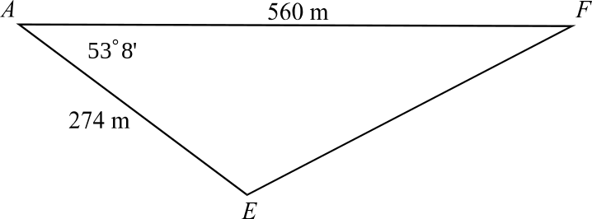
- In ΔAFE,

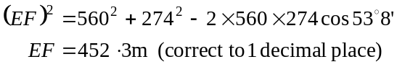
(1 mark) using the cosine rule
(1 mark) correct answer

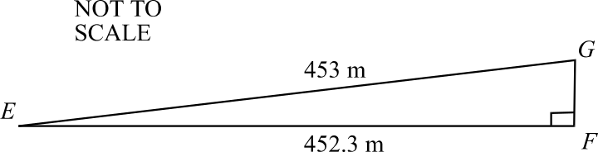
- In ΔEFG

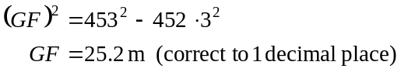
(1 mark)
The height of the old windmill is 25.2 metres (correct to 1 decimal place).

Module 3: Graphs and relations.

Question 1

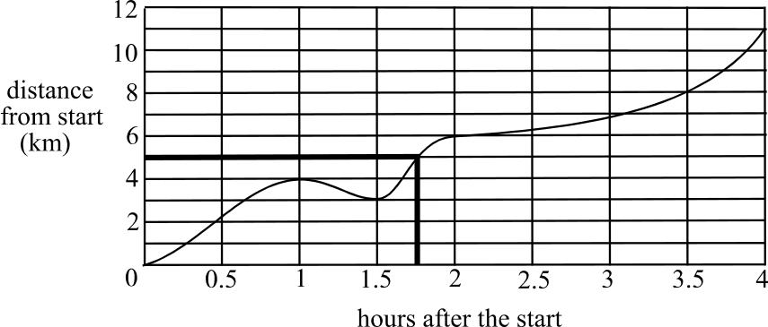

From the graph we see it took Mr Brown 1.75 hours to ride the first 5km of the course.
(1 mark)

- Between 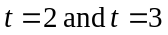, that is, during the third hour, Mr Brown covered the least distance. (1 mark)
This was because the gradient of the graph for that period was the least. (1 mark)

- Between 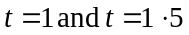 the distance between Mr Brown and the starting line of the walkathon decreases. Hence Mr Brown is riding back towards the starting line during this period.
(1 mark)

Question 2

- The rests occur when the line is horizontal; that is the distance from the starting point of the walkathon is not changing.
The first rest is for ¼ hour and the second is for ¼ hour. In total there is ½ hour of rest.
(1 mark)

- Kate is walking at her slowest when the gradient is least steep. Use a ruler to identify the least steep section of the graph. This occurs between 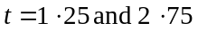 when the gradient of the graph is 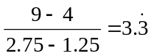
(1 mark)
- At . (1 mark)
So the gradient of this section of the graph is
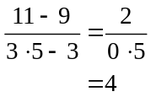
So Kate is walking at 4 km/hr between 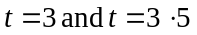.
(1 mark)
- From the graph, we see that Kate walks 11 km in the walkathon. So, she raises 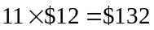 in total for the walkathon.
(1 mark)
Question 3

- i.
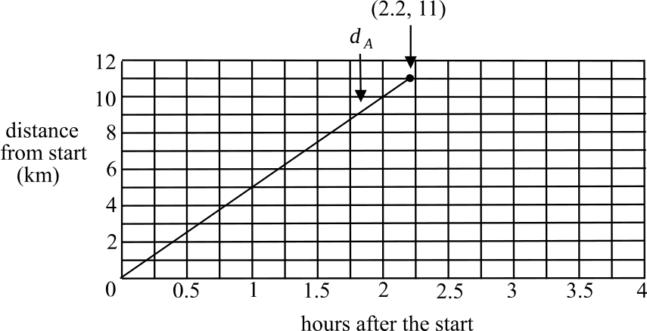

(1 mark)
  - The course is 11km long (from Question 1 part d.), and for Alexa 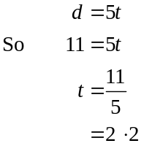
So 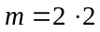.
(1 mark)
i.
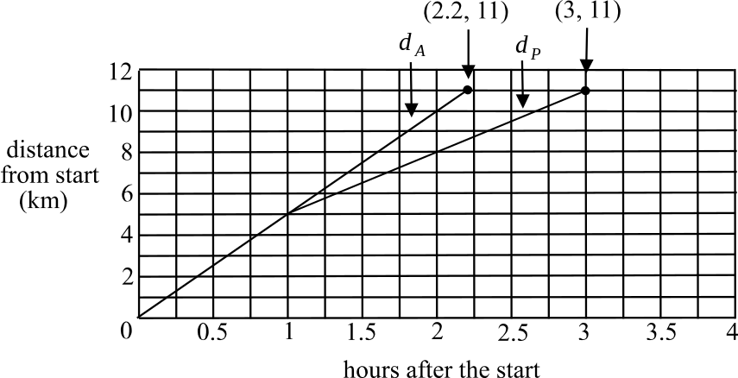
b. i.

(2 marks)
ii. For Peter, at the end of the walkathon, 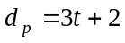.
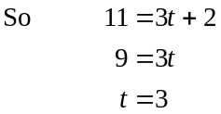
So 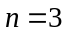.
(1 mark)
c. From the graph in Question 1, Kate takes 3 ½ hours to finish the walkathon course. From Question 2 part a. ii., Alexa takes 2.2 hours. So Alexa beats Kate by 1.3 hours.
(1 mark)
Total 15 marks

Module 4: Business-related mathematics.

Question 1

- 2.5% of $8500
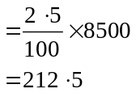
You would pay 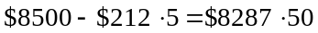
(1 mark)

- i. 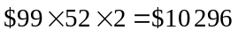
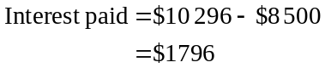
(1 mark)

- 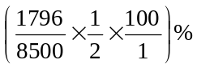
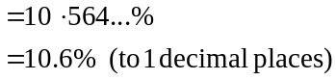
The annual flat rate of interest is 10.6%.
(1 mark) for omitting the half in the original line
(1 mark) for correct answer

Question 2

- Value after 5 years 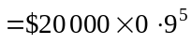 (reducing balance method)
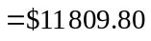
(1 mark) for correct type of depreciation
(1 mark) for correct answer

- Value after 5 years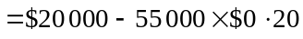 (unit cost method)
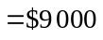
(1 mark) for correct type of depreciation
(1 mark) for correct answer

Question 3

- 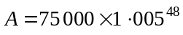
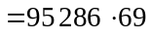 (1 mark)
Honest Harry would have earned $95 286.69 - $75 000 = $20 286.69
(1 mark)

- We require
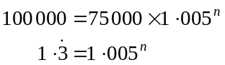
(1 mark)

Method 1
Trial and error.
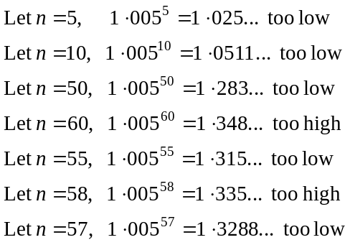
It would take 58 months to reach (and pass a little) $100 000. (1 mark)

Method 2
Use logarithms.
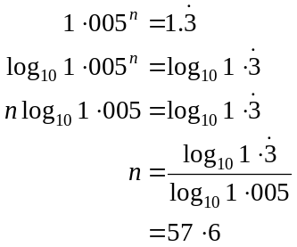
So it takes 58 months to reach (and pass a little) $100 000. (1 mark)

Question 4
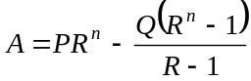
Given that the loan is paid off in 10 years and that 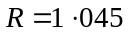, we have
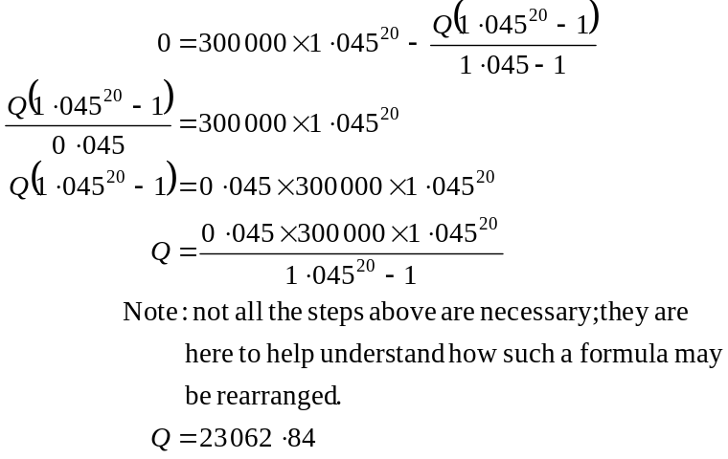
(1 mark)
(1 mark)

So the amount owing after 5 years is given by
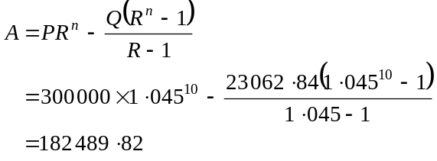
There is $182 489.82 owing after 5 years.
(1 mark)

Total 15 marks
Module 5: Networks and business mathematics

Question 1

- The shortest path from A to J is 225m long. (ABEGJ).
(1 mark)

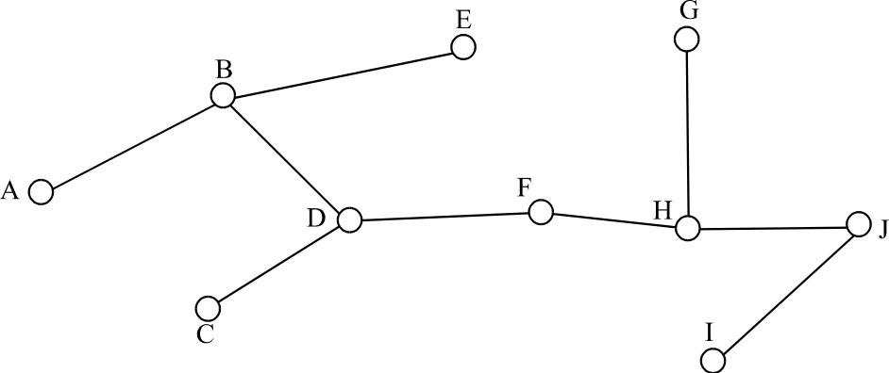

(2 marks)

Question 2

Using the Hungarian algorithm.
Step 1
Create a matrix from the table given.
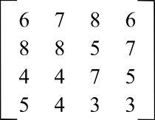

Step 2
Use row reduction to obtain the next matrix.
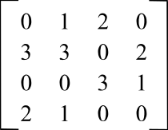

(1 mark)
Step 3
The second row contains only 1 zero.
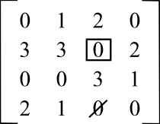
Box it and cross out any other zeros in
that column.

Step 4
The last row contains only 1 zero.
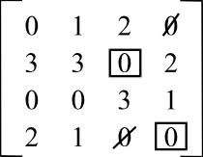
Box it and cross out any other zeros
in that column.

Step 5
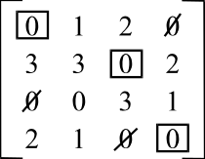
The first row contains only 1 zero.
Box it and cross out any other zeros
in that column.

(1 mark)

We have our optimal allocation.
Kate – construction costing
Monica – cash flow analysis
Gareth – financing
Ed – planning
(1 mark)

Question 3
- The capacity of the cut shown is 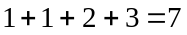.
Note that the arc GF is not counted since the water flows from J to A across the cut. The value 2 is not counted (and certainly not subtracted!) (1 mark)
- To find the maximum flow, we need to find the minimum cut. We do this by trial and error. There are two minimum cuts.
They are shown in the diagram below.
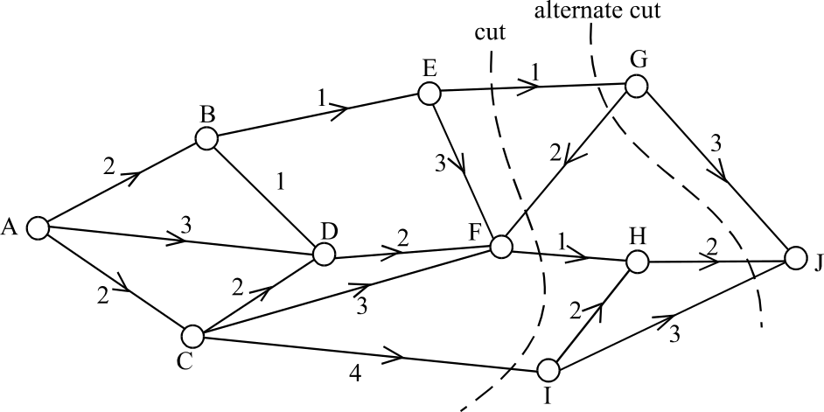

(2 marks)
The first cut has a capacity of 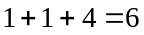. The alternate cut has a capacity of
1 + 2 + 3 = 6.
Hence the maximum flow per hour is 6mL.

Question 4
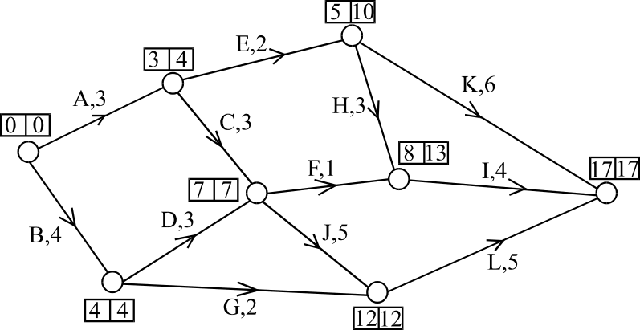

On the network above near each node are two numbers. The first is the earliest start time and the second is the latest start time.
The immediate predecessors of I are F and H. (1 mark)
The earliest start time for activity L is 12 weeks. (1 mark)
The latest start time for activity G is 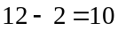 weeks. (1 mark)
- The critical path is B, D, J, L. (1 mark)
- Find the slack or float time for activities G and F.
Slack time for G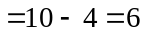
Slack time for H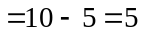
(1 mark)
If both activities are indefinitely delayed then activity H has only 5 hours of slack time compared to 6 hours of slack time for activity G. So activity H will be first to delay the project. (1 mark)
Total 15 marks

